**TABLE OF CONTENTS**

|  |  |  |
| --- | --- | --- |
| **SL.** | **CONTENTS** | PG |
| 1. | Introduction | 2 |
| 2. | Objective and scope | 2 |
| 3. | List of components and usage | 2 |
| 4. | Circuit Diagram | 8 |
| 5. | Methodology adopted | 10 |
| 6. | Merits and demerits of design | 13 |
| 7. | List of references |  |

INTRODUCTION:

This project is basically a simulation of a circuit which takes care of attendance and also prevents attendant’s from giving proxies (attendance for other attendants).This circuit note downs the attendance count of each student effectively and also tells them if they are having more than 65% of attendance or not with the help of LEDs .This system is implemented using collection of counters, seven-segment displays and comparators.

OBJECTIVE AND SCOPE

The objective of this project is to attain complete understanding about how we can implement most of any ideas using certain digital systems.(Here these are just some basic ICs).

It reminds us that counters are not only used to create required sequences but also in this process it stores the last value until the clock is triggered again. So we can cleverly use data that is stored according to our needs.

The scope of this system is almost everywhere as there will be some kind of gatherings everywhere which involves to know who have attended. It also has so much scope in any educational institutions. And this can also be extended to be used in offices or hospitals and any such works.

LIST OF COMPONENTS AND THEIR USAGE:

* IC 74LS138N (3:8 Decoder)
* IC 74LS90N (Decade counter)
* IC 74LS48N (BCD to seven segment decoder)
* Seven segment display
* IC 74LS32N (Quad 2 – input OR gates)
* IC 74LS85N (4-bit magnitude comparator)
* Resistors
* Voltage sources
* Probe
* Connecting wires
* Single pole double throw switch
* Dipswitch

1. IC 74LS138N (3:8 Decoder)

The 74LS138 is a high speed 1-of-8 Decoder/ Demultiplexer. This is nothing but normal 3:8 Decoder. It has mainly 3 section lines and 8 output lines and an enable pin. It helps us to divert the control to 8 different lines based on the 3 given input lines. This IC is compatible with all TTL families.

TRUTH TABLE:

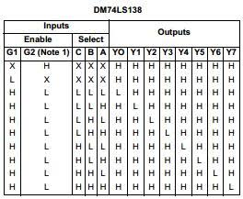

PIN DIAGRAM:

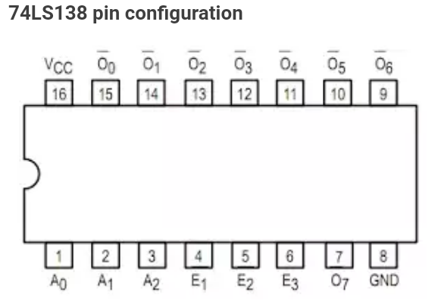

Basing on the activated output line operations are done on that respective student.

1. IC 74LS90N (Decade counter)

A decade counter is one that counts in decimal digits, rather than binary. A decade counter uses a cascaded set of mod 2 and mod 5 counters. The normal clock is passed to the mod 2 counter, and for the mod 5 counter the single output of the mod 2 counter is fed as a clock. As the mod 5 counter resets after reaching 100 and the mod 2 counter resets after 1,the entire counter resets after reaching 1001(nine), thereby functioning as DECADE COUNTER.

* ***State Diagram***

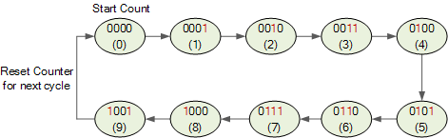

* ***Pin Diagram***

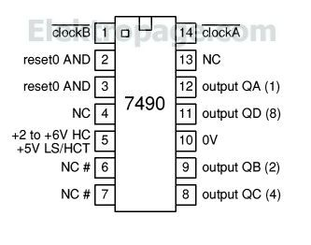

In this circuit one counter is assigned to each student and it is the one which stores the data of respective student.

3. IC 74LS48N (BCD to seven segment decoder)

A binary coded decimal (BCD) to 7-segment display decoder such as the TTL 74LS47 or 74LS48, have 4 BCD inputs and 7 output lines, one for each LED segment. This allows a smaller 4-bit binary number (half a byte) to be used to display all the denary numbers from 0 to 9 can be displayed with just a single byte of 8 data bits.

TRUTH TABLE:

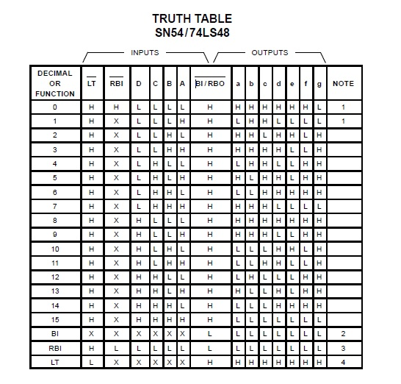

PIN DIAGRAM:

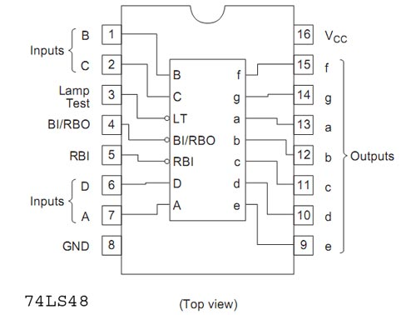

The outputs of this seven segment decoder logic are fed to the seven segment display through a series of resistors. Depending upon the output of the seven segment decoder the corresponding digits will be displayed.

1. SEVEN SEGMENT DISPLAY

7-segment LED (Light Emitting Diode) or LCD (Liquid Crystal Display) type displays, provide a very convenient way of displaying information or digital data in the form of numbers, letters or even alpha-numerical characters.

Typically 7 segment displays consist of seven individual coloured LED’s (called the segments), within one single display package. In order to produce the required numbers or HEX characters from 0 to 9 and A to F respectively, on the display the correct combination of LED segments need to be illuminated and **BCD to 7-segment Display Decoders** such as the 74LS47 does just that.

A standard 7-segment LED display generally has 8 input connections, one for each LED segment and one that acts as a common terminal or connection for all the internal display segments. Some single displays have also have an additional input pin to display a decimal point in their lower right or left hand corner.

In electronics there are two important types of 7-segment LED digital display:

1. ***The Common Cathode display***
2. ***The Common Anode display***

We use a common cathode display which is explained below.

The Common Cathode Display (CCD) – In the common cathode display, all the cathode connections of the LED’s are joined together to logic “0” or ground. The individual segments are illuminated by application of a “HIGH”, logic “1” signal to the individual Anode terminals.

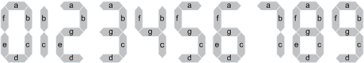

7-Segment Display Elements for all Numbers.

1. IC 74LS32N (Quad 2 – input OR gates)

It is a logic gate which takes in two inputs and gives one output. The output will be 1 any one of the inputs is 1. It would be 0 only if both of the inputs are 0.

1. IC 74LS85N (4-bit magnitude comparator)

This four-bit magnitude comparator has majorly 8 input lines and 3 output lines. This comparator performs comparison of straight binary and straight BCD (8-4-2-1) codes. Three fully decoded decisions are externally available as outputs.

TRUTH TABLE:

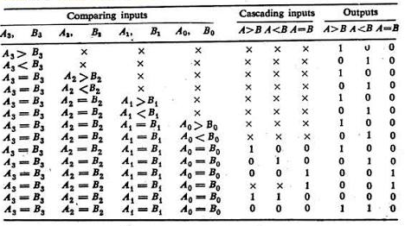

PIN DIAGRAM:

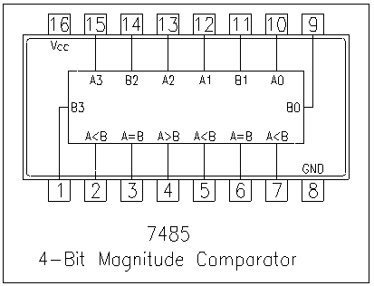

We use this to compare if the attendance of a student is up to 65% or not. Basing on this output probe is glown.

1. RESISTORS

While making connections between the outputs of BCD to seven segment decoder and seven segment display to limit the flow of current we use resistors. It is advisable to limit the current to 25-30 mA. Generally in practice resistors of resistance 150 to 220 ohms are connected in series between the outputs of seven segment decoder and the inputs of the seven segment display. We use a resistor pack with each resistance of 180 ohms in this project hence limiting the current to 5V/180 ohms= 28 mA

1. VOLTAGE SOURCE

We use two voltage sources. One is ground which be used to make the particular inputs low. To make them high we use VCC of particular high voltage. Here we set VCC as 5 volts.

1. PROBE

It is used as an indicator. It glows only when the input is high. Here we use 10 probes. We make use of their working feature and depending on the count displayed by the mod 10 seconds counter, the number of probes which glow will also increase accordingly. They will be reset after every 10seconds.

1. CONNECTING WIRES

They are used to connect different components with each other.

1. SINGLE POLE DOUBLE THROW SWITCH

It is used to connect a given part of a circuit to two different parts of a circuit with only one operational at a given point of time and it allows switching between two operations.

1. DIP SWITCH

It is used to connect and disconnect one part of circuit to other part of circuit.

MAIN CIRCUIT:

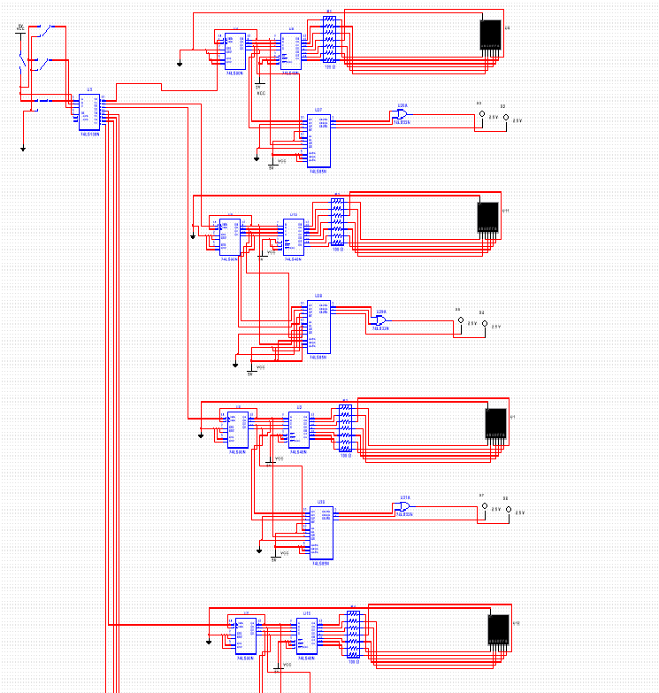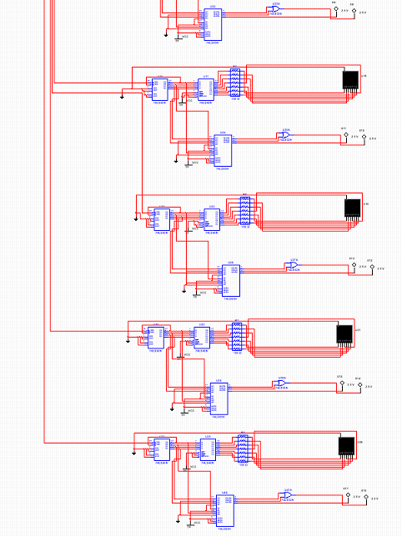

SUB CIRCUITS

1. NETWORK OF SWITCHES AND DEODER

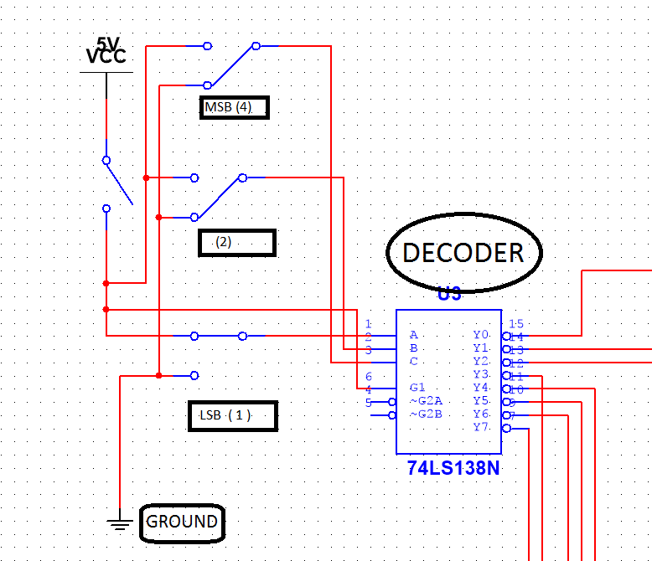

1. NETWORK OF COUNTER AND 7-SEGMENT DISPLAY

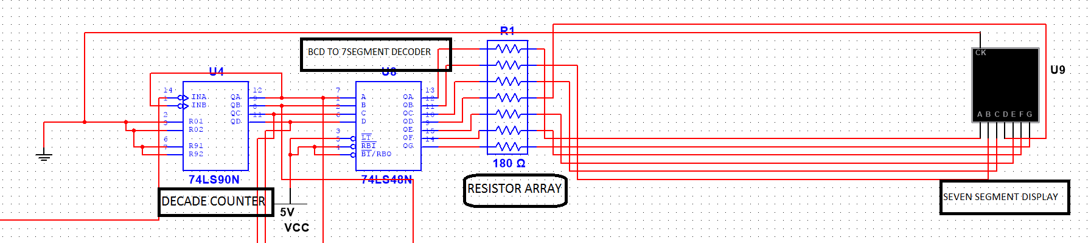

1. NETWORK OF COMPARATOR,AND GATE AND PROBES

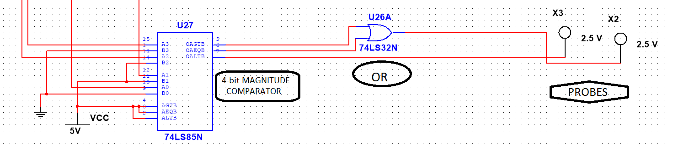

METHODOLOGY ADOPTED (IMPLEMENTATION)

* As this is a proto type, let us consider that there are 8 students in a class who have 9 classes to attend. And let us suppose that they must at least attend 65% of classes going on. So we require 8 different memory elements to store data regarding the attendance. For this purpose I used 8 decade counters one for each student.
* But to select the specific student the input (binary) is given through switches here.(But they are expected to be given by some type of scanner at arrival to each individual).And using this input respective counter must be selected. For this purpose I have used a 3:8 decoder which selects counter according to given 3-bit input.
* The output line of decoder is connected to decade counter at the clock pin. So the value in the counter increases only when the output line from decoder to that counter is one (as counter goes to next state only when clock rises from zero to positive value). Hence the data of attendance is updated.
* Now the output from decoder is fed to the BCD to seven segment decoder whose output is turn fed to the seven segment display through a pack of resistors of 180 ohms just to limit the magnitude of current. And this displays the number of total days respective student attended.
* Also the output from the decade counter is fed to 4-bit magnitude comparator; the other number is set to 6 (as 65% of 9 is approximately equal to 6). And the outputs from this comparator are connected to one red probe and one green probe.
* The output line from the comparator that shows that the value greater than 6 and the output line that shows that value is equal to 6 are fed to OR gate as input and output id given to green probe (As attendance must be equal to or greater than 6). The output line from comparator that shows that value is less than 6 is connected directly to red probe.
* As each student must have to have all of these this same set is repeated to other 7 output lines of 3:8 decoder.
* One main switch is added for the circuit which is expected to be switched on by some type of scanner only once per a person entering into the class room. But here as it’s a simulation we must switch it on and off every time we change the roll number that we enter.

MERITS AND DEMERITS

MERITS:

* Can be effectively used to calculate the attendance of each and every individual of the class.
* Strictly prohibits most of the proxies.
* No hectic work of taking attendance to teachers or lecturers.
* There will be no wastage of time as no attendance is to be taken.

DEMERITS:

* As there is a chance of student going into classroom and coming out and again any student can enter roll number of other student, lecturer is needed to come in prior to all students in class to prevent this.
* One student can sacrifice his/her attendance for his friend.